CHAPTER II: SYSTEM PROJECT CONTEXT

REQUIREMENTS MODELING

The project is specifically designed for the use of librarians and library users.

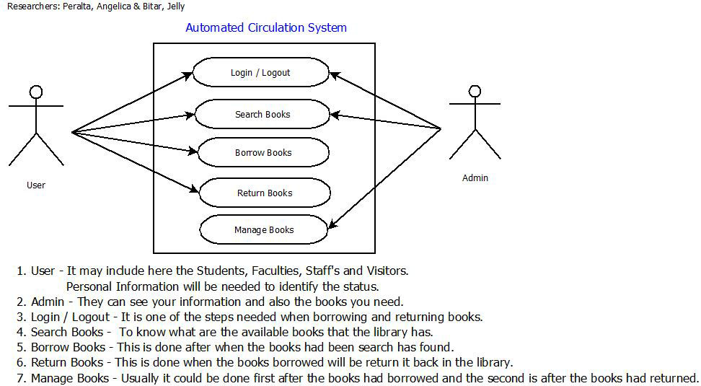

Figure 4 Use Case: Automated Circulation System

Librarian and users can log in/log out the account, search, return and barrow the books for library management process but the librarian can do only one thing is to manage the books that the users cannot do. It is especially useful for any educational institute where modifications in the content can be done easily according to requirements.

(EXAMPLE DESIGN…………………………………….)

SYSTEM DESIGN

❖ Search Books

 

Figure 9. Search Book

The planning and design of this new system, its construction and operation, basic functions, and routine and non‐routine output. It is designed to be flexible in accommodating amendments and additions at short notice, and with little or no reprogramming. Details the structure of the system control file, and the other advantages and interesting features deriving from its use. Indicates possible future developments, including the introduction of an on‐line system and isolates 3 defects: insecurity of data; consumption of time and possibility of human error; volume of paper produced.

**REFERENCES**

**Andrew Hague (2012)** the Raspberry Pi Education Manual Version 1.0

**Elsevier (2010)** Advances in Computers, Vol. 80

Elsevier Inc. (p.211) PDF FILE

**Benjamin Johnson (2012)** BARCODE EDUCATIONAL GUIDE

IDAutomation.com, Inc. (p.3) PDF FILE

**Luke McCathy (2004)**

The advantages and disadvantages of barcodes and radio

Frequency identification in supply chain management (p.8-10)

**Christophe Jechlitschek** (2013)

A Survey Paper on Radio Frequency Identification (RFID)

Radio Frequency Identification – RFID (p.5) PDF FILE

**Paul Cobalt (2015)** Linux Fundamentals Version 1.3

Free Software Foundation, Inc. (p.5) PDF FILE

**Machtelt Garrets (2010)**

Introduction to Linux A Hands-On Guide Third Edition

Fultus Corporation (p.7-10) PDF FILE

**Oguntoke Kawthar, Ayeni Joshua, Makinde Oladayo** (2015) Vol. 4

Development of a Circulation Library System (Case Study of T.Y Danjuma Library -Acu)

International Journal of Engineering and Computer Science

<http://www.ijecs.in/issue/v4-i2/11%20ijecs.pdf>

http://www.sesarju.eu/exploratory-research